Dunkin’ Donuts

Rising Stars Project

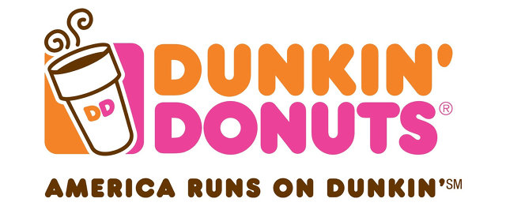

Courtney Emanuele, Sam White, Dori Gelman, Chris Banks, Caroline Scully

**PART I: SITUATION ANALYSIS**

Dunkin’ Donuts is owned by Dunkin’ Brands and is the world’s leading baked goods coffee chain. It serves over 3 million customers a day with over 11,000 restaurants worldwide. This includes 41 states and 36 different countries. Their current menu items include a variety of hot, iced, and frozen beverages along with bakery foods, wraps, sandwiches, and sides. They also sell different items for at home brewing options. Their priority statement is, “We strive to be recognized as a company that responsibly serves our guests, franchisees, employees, communities, business partners, and the interests of our planet.”

We will be introducing the promotion of Dunkin’ Donuts as a healthier fast food alternative. We want to incorporate a brand extension and customization options to their current menu items. We would like to implement pre/post workout food and beverages along with promoting their regular coffee. We want everyday people who enjoy working out, as well as athletes, to choose Dunkin’ Donuts for their choice of food and beverage before and after their workouts. We would also like to add an addition to the Dunkin’ Donuts mobile app. The addition to the app is an extension enabling users to make create and save customized orders, making ordering ~~our~~ new products easier and more efficient for the target market. We would like to test our new “healthier” position in Philadelphia and the greater Philadelphia area, however we would like to promote the new app extension nationally.

**Environmental Scan**

The key players are our overall competitors, Starbucks, Krispy Kreme, and McDonald's. For our research, the main competitors in the healthy post workout meals and drinks are companies such as Starbucks, Jamba Juice, and Seattle's Best. With competing menus of similar products, each company is creating new products and lines to cater towards the health conscious consumer that could hinder our sales. Dunkin’ needs to create a niche market to be seen as the leading healthy, fast, and on-the-go option. According to research done by DataMonitor Consumer, the five key trends in the coffee industry are cocooning, sensory fusion, ‘made for me’, on-the-go, and weight management. For Dunkin’, we are focused on creating personal and on-the-go healthier options consumers are looking for. With cocooning, people are making more of the coffee at home than purchasing daily cups, bringing the care experience to home. The leading motivation for this new cocooning trend is the economic downturn. People are looking for more inexpensive ways to maintain the level of coffee they drink without having to spend money every day. Dunkin’ Donuts has 27% of the market compared to the 43% hold of the major competitor, Starbucks. The other 30% is split up between three other companies. With these statistics, it is shown that although Dunkin’ Donuts takes up a large part of the market share, it is not the largest in the market.

**Current Marketing Overview**

*History/Future*

Dunkin’ Donuts was founded in 1950 by Bill Rosenburg, who opened the first Dunkin’ Donuts shop in Quincy, Massachusetts. The franchise has grown immensely over the past 65 years and it continues to expand. Now, they are planning on creating a delivery service next year along with its app update to implement this service (delish.com). They are also thinking about switching from Styrofoam to plastic cups in the near future. This is currently being tested in NYC, Massachusetts, Vermont, and California (huffingtonpost.com). Their biggest challenge is their sluggish fourth-quarter sales growth. They want to improve service speed and its international growth (wsj.com).

*Stage of product life cycle*

Dunkin’ Donuts is currently at the product maturity stage. They have high brand awareness and a wide range of distribution to many different countries. Their prices remain lower than their competition and they continue to have new product modifications. SmallBusiness says that “Dunkin’ Donuts markets it coffee drinks to those consumers who feel out of place in hip coffee shops,” (smallbusiness.chron.com).

*Market Positioning*

Dunkin’ Donuts wants to continue to have a simple goal. They want to be defined as the everyday, easy coffee shop that inspires rituals that revive. In addition, they want to continue to provide food and drink that’s fast, fresh, and affordable for their consumers.

*Sales History/Share of market*

Dunkin’ Donuts is currently in the fast food restaurant industry. Their current market symbol is DNKN and their price is $43.30. In 2013, their price was around $30, so they have been continually growing. They have to keep in check with their competition and learn from trends to keep growing. Dunkin’ is in a market that is shared with many other companies. Dunkin’ Donuts has 23% of the market, its main competitor, Starbucks, has 43%, while three other companies fill up the remaining 30%.

*Pricing and methods of distribution*

Dunkin’ Donuts is currently less expensive than its top competitor (Starbucks). They have over 11,000 stores open, which is significantly more than any other of their competitors other than McDonald’s. They can afford to keep their prices low, especially with a 30 million dollar budget for this region. In terms of distribution, they have a long term agreement for distribution. They will have a more streamlined system that will provide significant future cost-efficiencies for the franchise community. They will also have a consolidated Cooperative board structure and greater consistency in supply and distribution service levels to all US restaurants (investor.com).

**Communications History**

“America Runs On Dunkin’” has long been the slogan for the #1 hot and iced coffee spot in America, Dunkin’ Donuts. CMO John Costello says that it “is more than a slogan; it's really our brand purpose which is to help get you running in the morning and keep you running all day long.” Known to many people as simply “Dunkin’”, the company has a very large interactive marketing scheme including using various types on of TV, radio, and social media campaigns to encourage a wide variety of consumer generated content. Much of the most recent content has been focused around sports and professional athletes. It appears that Dunkin’ is striving to appeal to a male dominated target due to the masculine themes of recent marketing efforts.

The total advertising expenditures for Dunkin’ Donuts Restaurant in 2014 was $134 million. Of that, 52.9% ($66,7M) was used in Spot TV efforts. The second most is Cable TV with 24.6% ($31M) followed by Outdoor Ads with 8.4% ($10.7M), US Internet at 6.3% ($7.9M), and Nat. Spot Radio at 5.1% ($6.4M) and finally Network TV with .5% ($674,000).

A clear indication of Dunkin’ Donuts’ increased online presence is the Dunkin’ Donuts YouTube channel. It contains over 100 videos of commercials, behind the scenes looks, and other exclusive content. Over the summer months of 2015, the brand launched a campaign featuring two mega athletes, the NFL’s Rob “Gronk” Gronkowski and the MLB’s David “Big Papi” Ortiz. The campaign, called “Summer Chill,” included a series of YouTube video featuring the athletes enjoying Dunkin’s iced coffees while speaking about their other favorite summer items and activities. The videos were featured in online advertisements, on the YouTube channel, and on the campaign website (www.summerchill.com). Following this, Dunkin’ Donuts started a football themed campaign with the start of the 2015 NFL and NCAA football season. The first of this series is called “Camp Commitment”, starring NFL superstars Eli Manning and Odell Beckham Jr. Playing off of the idea that “Great Coffee takes Commitment,” the campaign featured various videos of the duo participating in activities at an imaginary “Camp Commitment.” The second installment, named field pass, includes a series of videos with three football players in bright orange DD jerseys performing outrageous touchdown celebrations. The website, www.Ddfieldpass.com, encouraged consumers to upload their own creative content featuring Dunkin’ products. All of the videos have a wide range of “views,” from 500-50,000.

The newest and biggest change to the marketing mix is the implementation of a completely Mobile reward program, scrapping the original paper and web DD Perks. The CMO is quoted stating the change was a stun in “developing a mobile-centric program were ensuring that the DD Perks loyalty program was customer-focused, fast and enhanced the in-store environment.”

A more commonly known campaign to the Philadelphia area is “Eagles win, you win!” that offers free coffee the day after the Philadelphia Eagles NFL team wins a game. Described on the website [*http://ddeagleswin.com/*](http://ddeagleswin.com/), through the mobile app, customers can claim their coffee at any participating locations.

One of the largest exposure-based campaigns Dunkin’ Donuts orchestrated was signing on as a full-season backer of NBC's hit variety show, America’s Got Talent. Ad Age states that, “Dunkin’ Donuts will be featured throughout each of the 26 episodes of "America's Got Talent"; placement includes Dunkin’ Donuts coffee cups conspicuously perched in front of judges Howard Stern, Heidi Klum, Howie Mandel and Mel B.” In 2014, the show was rated as the most-watched summer program on broadcast TV, averaging 10.2 million viewers. The contract also includes a Dunkin’ Donuts lounge for the contestants and exclusive insights through the app and webpage.

Social media presence is clearly abundant, with multiple posts on all platforms everyday featuring promotions, announcements, and humor. Dunkin’ Donuts has a large presence of social media that is growing every day. Their accounts are as followed:

· Twitter – 980k followers

· Instagram – 576k followers (seems to be female oriented)

· Facebook – 1.4M likes

· Regularly updated blog - [*http://www.Dunkin’donuts.com/DDBlog.html*](http://www.dunkindonuts.com/DDBlog.html)

Dunkin’ Donuts uses different boutique companies for different aspects of their marketing. The agencies that Dunkin’ Donuts uses are as followed:

* H[ill Holliday](http://www.redbooks.com.ezproxy.sju.edu/ad_agency/HILL_HOLLIDAY) 
  + (Campaign: "#MyDunkin’", Campaign: "Dunkin’ Iced Coffee Creator", Digital Media Buying/Planning, Flatbread Sandwiches, Personal Pizzas, Wake-Up Wrap?
* Z[ubi Advertising Services, Inc.](http://www.redbooks.com.ezproxy.sju.edu/ad_agency/ZUBI_ADVERTISING_SERVICES_INCORPORATED) 
  + Creative, Digital, Pr, Promotions, Social Media
  + (Hispanic Marketing, Pr)
* V[ML, Inc.](http://www.redbooks.com.ezproxy.sju.edu/ad_agency/United_States/Atlanta/VML_INCORPORATED) 
  + Digital Marketing (Agency Of Record)
  + (Digital Marketing (Agency Of Record))
* F[ish Consulting, Inc.](http://www.redbooks.com.ezproxy.sju.edu/ad_agency/FISH_CONSULTING_INCORPORATED) 
  + Event Marketing, Public Relations, Social Media
  + DigitasLBi
  + (Loyalty Marketing)
* L[a Torre Communications](http://www.redbooks.com.ezproxy.sju.edu/ad_agency/LA_TORRE_COMMUNICATIONS) 
  + (Dunkin’ Donuts)
* Zimmerman Advertising
* Sprokkit
* Hill and Partners
* Fresh Media Group
* South Paw
* Kaizo

**Target Audience**

Coffee shops and shops that sell donuts are one of the largest industries in the United States. 54% of Americans over the age of 18 drink coffee every day, and a large percentage of those drinkers have more than one cup a day. Generally, the main target market of Dunkin’ Donuts, in general, is adults from the ages of 25-55 years of age, who are working class and of all races and genders. Dunkin’ drinkers tend to be social moms, sports fanatics, and family travellers. The main consumer makes approximately $40,000-$100,000 per year and are working professionals. They are very practical and tend to go towards advertisements that aren’t flashy.

Dunkin’ Donuts has most shops in suburban and urban areas in locations across the country, mainly focusing on areas in the East Coast. The company has been taking strides to widen their target market to keep up with the modern times. This comes with changing their menu to ensure that they are affordable and that their options are varied. This shows that the changes in the menu that we propose will be more widely accepted as it shows that the Dunkin’ Donuts customer is already accepting of change. Currently, about 56% of Dunkin’ Donuts customers report that they work out several times a month. In addition, 33% of consumers who go to coffee houses or donut shops say that they are ordering healthy items.

Dunkin’ Donuts consumers are less likely to use social media outlets and other smart phone apps. They are more attached to more traditional forms of media, such as television and magazine. Dunkin’ Donuts consumers tend to watch channels such as FOX, MSNBC, and ESPN. These consumers are also 64% more likely to want to a more logical solution over a creative solution. Out of the consumers, 47% say that they are night owls whereas 40% say that they are morning people. The younger portion of the consumers, aged 25-34, say that peer input is important to decision making and that they look for word-of-mouth when making their decisions while the older consumers tend to rely on themselves and the customer service within the store to help them make decisions.

The consumer is very satisfied with the current state of Dunkin’ Donuts. Out of the top coffee shops, they have the highest level of brand loyalty and have a 61% intent to return. When mentioned, consumers have a 74% positive reaction to the menu and coffee, with a 63% positive reaction to the hot coffee and the 79% positive reaction to the iced coffee.

**Competitive Assessment**

Global whey protein market had a value of $5.4 billion in 2014. The market is expected to reach $8.4 billion by 2020. A post workout drink called Muscle Milk owns a large portion of the market share, however athlete are beginning to dislike it more because of its ingredients and the damage that it causes internally to our bodies and muscles. It’s not natural and some of the stuff in the “milk” does more harm than good which in theory defeats the purpose of a good workout. There are studies (Mensfitness) that show that people would prefer to have natural products enter their bodies thus completing the idea of a good workout. But in retrospect, people work out to “look” a certain way, and these products that contain unhealthy ingredients are a shortcut and effective way to get our bodies to look the way we want them too. For example, “Muscle milk has been known to trigger allergies, cause trouble with the kidneys, and contain “fats” that are known to cause trouble with muscle growth.”

Due to recent research we have found that coffee is good for pre workout energy source. This can replace the high sugar drinks such as Red Bull and Monster; or even the pre-workout powder, C4. These products have high amounts of sugar that cause the body to overuse muscles that cause injury due to improper nutrition. But again, people are focused on immediate results making them more susceptible to like the sugar-rush making them feel ready to take on a tough workout. People are all about instant gratification, not exactly results that they cannot see. There has been tragic incidents involving red bull and the amount of sugar in it. A person once has died because he “drank several cans of the energy drink after a strenuous workout and later died of massive kidney failure.” The other ingredients such as taurine and synthetic ginseng are very detrimental to the body as well.

In conclusion, all these products are not natural nor healthy for the body, especially when it comes to working out. The competition that share our target market would be brands that make products for people who are into working out or anything that relates to athletics. Trying to persuade our target market that switching to a more natural alternative option with workout drinks and high-protein food would be healthier and more effective for consumers.

**PART II: ADVERTISING CAMPAIGN**

**Advertising Objectives and Overall Budget**

1. Increase market share to 27% from 30% in 12 months with new products and marketing campaign.
2. Increase overall net sales from 2015 sales ($545.19M), allowing for more budget the following fiscal year.
3. Change perception and attitude that consumers have of Dunkin’ Donuts brand from being categorized as an unhealthy fast food restaurant to a restaurant that values its customers and their health with the new ingredients and a meal customization app.
4. Increase brand awareness of Dunkin’ Donuts mobile app.
   1. Cultural: Norms and values
   2. Social: Lifestyle
5. With a budget of $30-35 million, we plan to promote our products to a specific demographic through commercials, ads in magazines and other forms of traditional media.

**Creative (Communications) Brief**

We want to introduce Dunkin’ Donuts coffee as a healthier alternative to pre-workout energy supplements. We will also incorporate new food ingredients to create new products by Dunkin’ Donuts that are healthier alternatives to donuts, bagels, and other foods already on the menu. Along with the coffee choice, we want the food to act as a pre and post-workout energy. We want our customers to also be able to customize their order according to how they want it. Further detail about this great new experience will be explained later in the campaign.

Unlike Dunkin’ Donuts’ main target audience, which is very broad, our target audience iswill be 25-35 year-old, health conscious, with any level of active lifestyle. The target audience can range from runners, to yoga-goers, to weight trainers (racompton). We want to keep reaching to our brand loyal customers, but change their experience with the brand to promote a ~~new~~ healthy lifestyle and by showing we care about their health. We want Dunkin’ Donuts coffee to be people’s first choice before their daily workout routine and sandwiches for after. The target audience is motivated by anything that will improve their workout experience and results.

If there is one thing all athletes can never get enough of, its gear: look in any athletes laundry baskets and without a doubt you’ll find an abundance of stinky athletic-style socks, shorts, and t-shirts. For a band imperative, we want people to be running *with* Dunkin’s gear on, so to reward our top social media sharers we are giving away DD activewear including dry-fit t-shirts, shorts, and socks for both males and females with the Dunkin’ Donuts logo.

Promotions and sponsoring athletic events is a good way to create awareness and involve sampling. We want to sponsor a Philadelphia New Year’s Eve 5K run and promote our new products and brand ideas. Before the race, we will have Dunkin’ Donuts trucks and tents lined up with our new pre-workout products and foods. There will be stations at every mile of a water table with the Dunkin’ Donuts logo on it. Finally, at the finish line we will have our post-workout products set up for everyone to sample and buy. We will be able to get direct feedback and evaluations from users and take this information to either improve or expand with the brand extension.

**Creative Strategy**

Our Big Idea for Dunkin’ Donuts is the introduction of a new and improved Dunkin’ Donuts application for mobile devices that includes a customizing option so consumers can create their own meals using healthier ~~food~~ ingredients and drink alternatives.

We would like to add an extension to the Dunkin’ Donuts app so customers will have the opportunity to custom create their own meals including selecting the ingredients of their own sandwiches, coffees, and smoothies. Each item and order will be saved in the app, letting customers easily re-order previous orders by scanning the custom barcode the app will create on their phones. The app will also feature the nutritional facts of the custom created meal, giving health conscious customers the option to know the details of what they are eating. We hope that this will promote an easy and fast experience when a customer goes to Dunkin’ Donuts before or after their workout. With this new customization feature customers can choose from various new meats, vegetarian alternatives, dairy, and breads. Our new menu will introduce the additions of spinach wraps, gluten free wraps, and whole wheat wraps to the bread section. Pepper jack and provolone will be our new featured cheeses on the menu. We will also introduce the addition of cage-free eggs along with protein powder to be used in smoothies per customer request.

Our Positioning Statement for Dunkin’ Donuts is that “we want our consumers to know what they are putting in their body and we are committed to giving them the absolute best with our new healthier customization menu with the Dunkin’ Donuts name you already run on.”

Dunkin’ Donuts is committed to making sure that our customers are completely satisfied. “[We] are committed to providing guests with the best-testing, high-quality food and beverages…[we] strive to be recognized as a company that responsibly serves our guests, franchisees, communities, and business partners,” (Press Kit). Our goal is to take that commitment one step forward. Through our repurposing of black coffee as a pre-workout drink and our new customization abilities to help customers make healthy decisions, we want our customers to know that we are behind them in each decision that they make. As a company, Dunkin’ Donuts is striving to ensure that our customers feel supported in every step of the way. We want our message to clearly radiate positivity and motivation. We want our customers to know that during their strive to become healthier; Dunkin’ Donuts is behind them one hundred percent.

The slogan we will run on all our new advertisements is “Run Better On Dunkin’”, a play on the “America Runs on Dunkin’” but with our own healthy lifestyle spin.

Dunkin’ Donuts has been the official coffee, donut and breakfast sandwich of the Philadelphia Eagles since 2013, according to the *Philadelphia Business Journal.* In 2013, Eagles announced the return of the popular “Eagles Win. You Win!” free coffee offer and in 2013 alone fans redeemed over 600,000 cups of free coffee through the popular “Eagles Win, You Win!” mobile offer. This exclusive offer for fans celebrates each Eagles victory with a coupon delivered on the Dunkin’ Mobile App for a free medium hot or iced coffee valid in the Greater Philadelphia Region the day following an Eagles win (Philadelphia Eagles.com). To introduce our upgraded app we want to revamp the endorsement deal that Dunkin’ Donuts holds with The Philadelphia Eagles by incorporating the players into our new ‘Athlete Sandwich Spotlight’ promotion where consumers are able to order the sandwich their favorite Eagles player has created. With this service being brand new, we would like to get as much awareness as possible within the budget. To ensure success we will be using the advertising method of wrapping busses. This method consists of customized ads placed on doors of SEPTA buses. These ads are drawn to promote our new product line and get the new marketing campaign message across. “Customize without the guilt” is the message chosen to show the people to promote the new product line.

**Media Strategy**

*Traditional Media*

We decided to allocate a large portion of the budget to traditional media due to the target markets tendency to use expose themselves to it over digital media platforms. In 2014, Dunkin’ Brand said that the traditional media advertising efforts will span across a wide range of vehicles, including many outdoor ads as well as broadcasted. Our goal with the traditional media is to gain as many pure impressions as we can to promote the awareness of the new app and Dunkin’s efforts to assist consumers in living a healthier life. We believe the selections we made for traditional media will result in a large reach to our targeted market as well as give enough frequency to encourage trial and enhance recognition as a superior fast food restaurant selection. For traditional media, we plan on utilizing multiple different vehicles including the following:

*Print*

Men’s Health Magazine has a readership of 12.5 million, 84% male, predominantly middle class, with a median aged reader being 40 years old. Although the demographic is not our exact target market, it directly corresponds to Dunkin’s previous market while include a large section of our target. We firmly believe the Men’s Health exposure will greatly promote the introduction of our new position focused on health to loyal customers as well as gain a vast amount of targeted impressions. The full-page ads will cost $237,980 each, meaning a total of $1,427,880 will be spent in Men’s Health Magazine. We plan to run one full-page ad in 6 issue that we feel best corresponded to our new position:

* + Jan/Feb 2016 - *The 21 Day Transformation issue*
  + *March 2016 - Spring Style Issue*
  + *May 2016 The 3rd-Annual Fitness Awards*
  + *June 2016 - The Food Issue*
  + *October 2016 - The NFL Issue*
  + *December 2016 - The Tech and Gear Issue*

*(http://www.menshealthmediakit.com/print-editoria*

*calendar/2ybwicmgeq6xb8ggw60dpsf5r9amug)*

We also would like to feature ads in Women’s Health magazine. Women’s Health has a readership of 1.1 million, predominantly middle class, with an average reader age of 36. We hope that through this vehicle we can reach women who would like to make a healthier decision when choosing a fast food restaurant for themselves and he potential family. We plan on entering one ½ page ad in every other monthly issue of Women’s Health (ei. Jan, March, May, etc). At $133,640 per ad, we will spend $801,840 annually.

The second form of printed traditional media we plan to utilize is the Philadelphia Inquirer. We feel that the demographic will align very well to gain extensive exposure to an older demographic of Philadelphians and Greater Philadelphia residents. The paper has 1,067,128 Sunday readers with an Average age of 53, 45% male and 55% female. Ads will cost an average of $5000 per ad. We would like to spend $520,000, running two 5”x5” ads in every other Sunday newspaper throughout 2016.

*Broadcast*

When we considered who is most likely to make purchases at fast food restaurants, we believe people who ride/drive cars to be one of the highest demographics. For this reason, we have decided to use two of Philadelphia's most prominent radio shows. Both stations average listeners age is 35-36, are working-middle class, and own automobiles; these specifics correlate with the desired target market we would like to reach. We estimate that a 30 second spot on both stations will cost an average of about $500 per ad. We would like to have moderate frequency, featuring 4 ads per day; two during the morning commute hours and two during the evening commute hours.

93.3 WMMR is Philadelphia's home for Rock music. It has a 60% male audience with an average age of 36. We will allocate $730,000 annually to this station for advertising, giving us 1460 annual ads.

Radio 104.5 is Philadelphia’s home for Alternative Rock music. Their highest demographic of listeners is 25-34 year olds at 27.9%. The average age of listeners is 34, with 54% males. We have decided to allocate $730,000 annually for advertisements featured on this station twice a day, giving us 1460 ads annually.

We believe that the 2016 Super Bowl would be a great place to reach a large amount of our target market. With an enormous and very diverse audience, we know it will be an important investment to make, seeing as Dunkin’s previous target market has a very broad demographic. An average Super Bowl commercial costs $4.5 million. We hope to feature the commercial close to half time.

The 2016 Big Bang Theory season on CBS is our Network TV selection to feature commercials periodically. The average age of viewer is 25-54 and has an average of 13.35 million viewers a week. We feel between the frequency and large reach, the commercials will result in a large amount of weight. We would like to “book shelf” the TV show with 2 ads, one in the beginning and one at the end. At $344,827 per 30 second ad, and 24 episodes a year, we will be spending $16.5 million on Big Bang Theory advertisements.

*Outdoor*

We would like to allocate a large amount of our budget to outdoor advertising efforts. We believe that a large amount of potential Dunkin’ Donuts customers can be reached through outdoor advertisements. In 2014, Dunkin’ Donuts spent $11 million on outdoor advertisements, 8.1% of their overall budget. They are a great way to increase brand recall when deciding on a quick meal as well as to influence people to try out the new customization app.

We have decided to place advertisements on two prominent billboards (within the top 10 highest estimated impressions) in the heart of Philadelphia:

* N/S Vine St Expwy (I-676) @ 6th & Callowhill Streets F/W - Philadelphia, PA
  + 306,100 weekly impressions
* N/S Schuylkill Expressway (I-76) @ 20th Street F/E - Philadelphia, PA
  + 481,200 weekly impressions

Each billboard will feature the ads for six different 4-week periods throughout the year. For each 4-week span, the billboard space will cost $15,000 each, meaning we will allocate $360,000 annually to the two billboards. Months were chosen specifically for time we felt would be most relatable to our new position. These months include colder months and months prior to beach season, however we would also like to have moderate frequency to promote recognition and return customers.

We would like to place a half-bus wrap and interior bus wrap advertisements on 30 SEPTA Buses in Philadelphia. We plan on placing the advertising combinations on buses that pass at least 1 Dunkin’ Donut restaurants on its route. The ads will be featured on 30 SEPTA buses for nine, nonconsecutive, 4-week periods. The wraps cost $2000 per 4-week period and the interior will cost $75 per 4-week period, meaning we will spend $560,250 on bus advertising annually.

*Digital Media*

We want to include digital media to not only reach our current target market, but also the younger target who we want to reach with our new campaign. In the way of digital media, we want to primarily use YouTube videos, YouTube advertisements, and Facebook advertising. We wish to reach the younger demographic in a way that is effective and cost friendly. YouTube advertisements will cost 10-30 cents when the viewer watches more than thirty seconds of the video. Our creative efforts have led us to develop commercials that are tailored to grab attention and keep a viewer watching longer. We want to spend a maximum of $2 million annually on YouTube advertisements. For Facebook advertising, we plan on doing sidebar and in feed advertisements. We would like to limit our expenditure to be $100 a day. Using the Facebook market section selection tools, we will isolate the ads to only be shown to potential consumers in the Philadelphia and Greater PHL area, working-middle class, and between the ages of 30-40 years old. The annual expenditure sum for Facebook advertising will be $2,000,000.

We would like to allocate $30,000 to sponsoring a native advertising article on Buzz Feed. We chose this media platform due to the similarities between our target market and their reader demographic. Buzz Feed’s reader demographic include 50% that are 18-34 year old middle class citizens (BuzzFeed Media Kit). This form of incognito advertising has a unique ability to have a lasting effect on the brand’s image. The article will not directly advertise the Dunkin’ Donuts app, but rather it will promote overall well-being of the customer. We hope that this will help re-categorize Dunkin’ Donuts as a healthier alternative to traditional fast food.

We would like to feature advertisements on mobile devices and mobile apps using Apple’s iAd technology. The technology will allow us to focus our marketing efforts on our specific demographics, giving us a greater reach to consumers who we feel meet our target market criteria. Although plans start at $120, we would like to allocate $1,000,000 to mobile advertising efforts. We hope the frequency of ads will encourage repeat customers through a higher recall rate of Dunkin’ Donuts new position and product customization.

**Other IMC Tools**

In 2014, runbucks.com organized a New Year’s Eve 5K running event, where people can come to run a 5K in eveningwear. We want Dunkin’ Donuts to be a part of the action and be one of the sponsors of the event. During the event, we want to sell t-shirts with the Dunkin’ Donuts logo on the back along with the name on the back. On the front of the t-shirt, it will be a fun design of a tuxedo for men, and an evening top for women. People may choose to purchase these shirts to wear during the 5K. We want to add sampling stations along the race to help promote our new products. At the start of the race, we will provide our new pre-workout products as well as classic Dunkin’ Donuts coffee, with the options to try a sample or buy a larger portion. We will have water stations to fill up complimentary Dunkin’ Donuts water bottles provided before the race, with our logo on the water stations. At the finish line, runners will be offered samples of post-workout options as well as coffee, if the runners would like to taste or buy. The first three winners will be awarded different Dunkin’ Donuts products and prizes.

On Twitter, we want to have a promotional contest that our customers can get involved with. We want customers to tweet using the hashtag #IRunOn and posting a picture of their customized Dunkin’ Donuts sandwich. The customer with the most creative picture, wins the contest. The promotion will start January 1, 2016 and will go until January 15, 2016. The winner will be announced on the last day and will receive an athletic t-shirt, a water bottle, and a hat with Dunkin’ Donuts, and coupons for future purchases.

We would like to incorporate new forms of advertising efforts into the IMC mix as well. We will utilize the new trend of “Native Advertising” on Buzz Feed. Our Native Advertising will be a traditional Buzz Feed “list” article that is sponsored by Dunkin’ Donuts. We would like to work with a Buzz Feed writer in order to produce an article about mobile applications that will assist with improving health. Included at the beginning and end of the article will be a short but informative description of the new functions of the Dunkin’ Donuts App. The article will promote the image of Dunkin’ Donuts by showing the new position that they do care about the health of their customer.

**Advertising Evaluations**

In order to clearly evaluate our marketing efforts we would like to increase the Dunkin’ Donuts app by 4 million downloads.  The current app has just over 14,000,000 downloads, we would consider our marketing efforts a success if we can increase downloads to 18,000,000.  The increase in downloads will demonstrate a large awareness and new loyalty to the brand.  The app will also keep count of how many sandwiches and drinks are created, as well as how many different combinations are made.  The tracker will allow Dunkin’ Donuts to track what items are most popular.  In order to assess if the new “healthier” position is effective in the Philadelphia area by the amount of healthier ingredients are used in the new sandwiches.

**Appendix**

*App:*

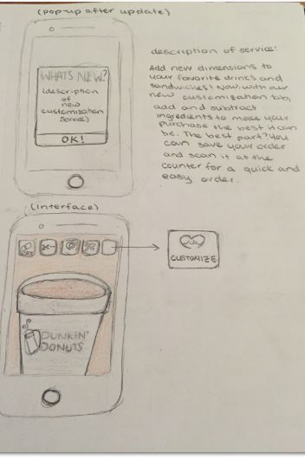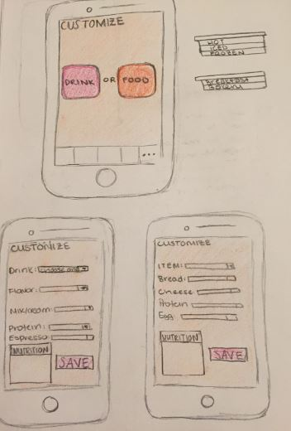

*Television:*

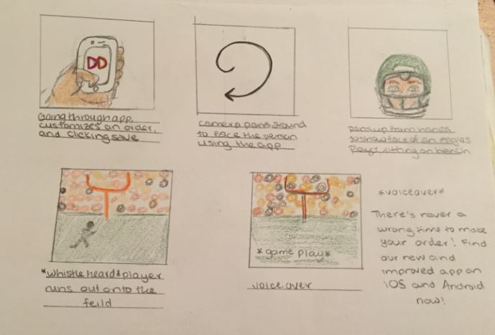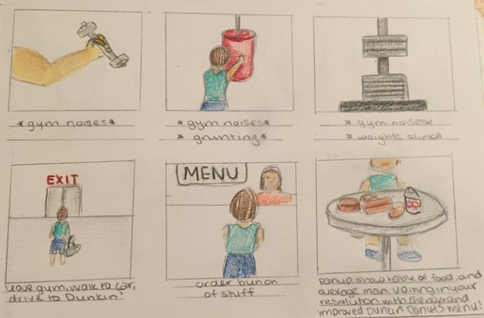

*Radio*

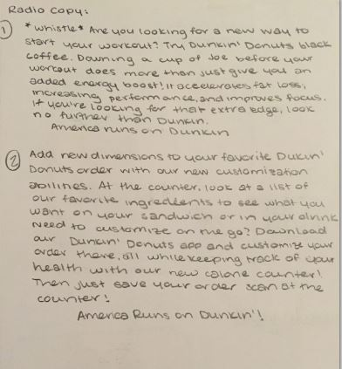

*Newspaper*

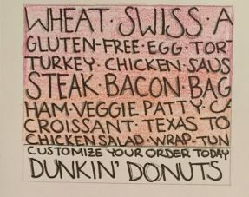

*Magazine*

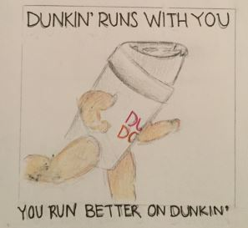

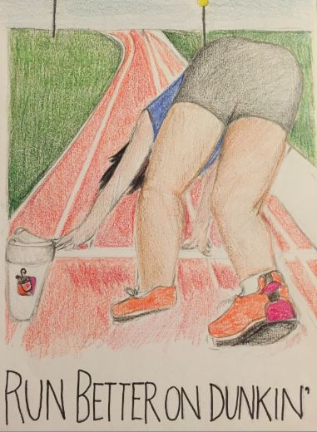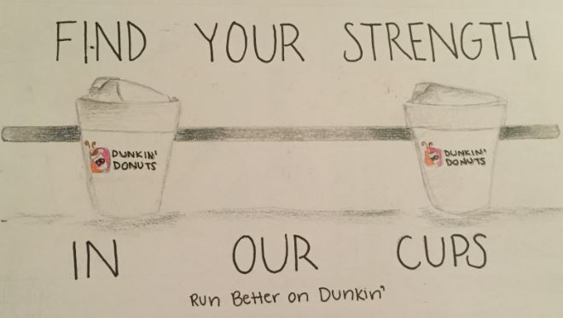

**OOH**

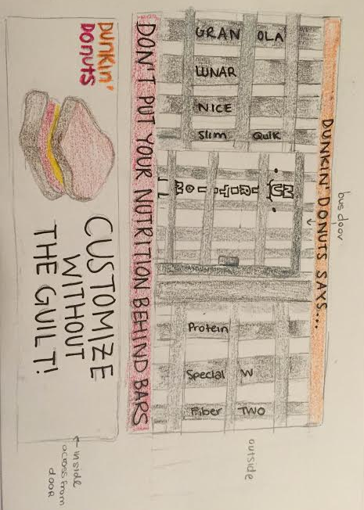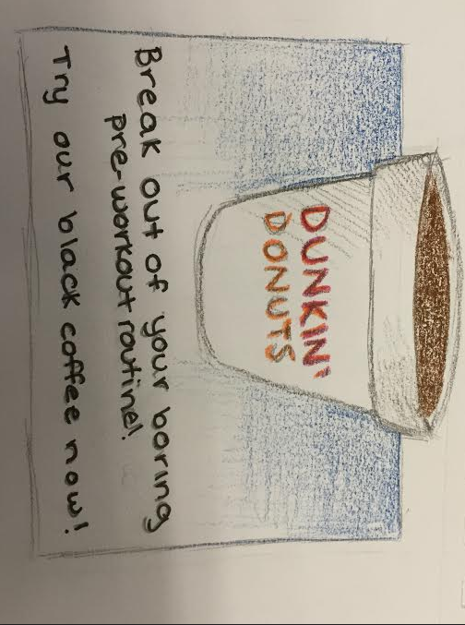

Billboard Bus wrap

Works Cited

"2015 PHILADELPHIA NEW YEAR's EVE MIDNIGHT RUN 5K." *Eventbrite*. N.p., n.d. Web.

22 Nov. 2015.

"3 Major Muscle Milk Side Effects." *Healthline*. N.p., 16 Dec. 2014. Web. 22 Nov. 2015.

"Audience." *Men's Health*. N.p., n.d. Web. 22 Nov. 2015.

"Big Bang Theory Extended to 2016-2017: Multi-Year Pick Up - CBS.com." *CBS*. N.p., n.d.

Web. 22 Nov. 2015.

"CBS's 'The Big Bang Theory' Tops Thursday in Viewers & Key Demographics." *TV By The*

*Numbers by Zap2itcom*. N.p., 03 Apr. 2015. Web. 22 Nov. 2015.

"Coffee Concepts Can Target Lunch Guests with Demographic Data." *Erica*. N.p., 23 Nov. 2014.

Web. 22 Nov. 2015.

"Crush Your Workouts With Coffee." *Men's Fitness*. N.p., 12 May 2013. Web. 22 Nov. 2015.

"Dunkin’ Brands Sales Growth Slows." *WSJ*. N.p., n.d. Web. 22 Nov. 2015.

"Dunkin’ Brands Signs Exclusive Procurement & Distribution Agreement With Dunkin’ Donuts

Franchisee-Owned Cooperative." *(NASDAQ:DNKN)*. N.p., 04 Jan. 2012. Web. 22 Nov.

2015.

##### Dunkin’ Donuts 10k-2015

Dunkin’ Donuts 10q-2014-15

"Dunkin’ Donuts." *Dunkin’ Donuts News*. N.p., n.d. Web. 22 Nov. 2015.

"Dunkin’ Donuts Now Delivering, So You Don't Even Have to Move to Get Coffee." *Delish*.

N.p., 18 Nov.

"Dunkin’ Donuts Press Kit." *Dunkin’ Donuts Press Kit*. N.p., 17 Aug. 2015. Web. 22 Nov. 2015.

"Football and 'Big Bang' Are Broadcast TV's Most Expensive Ad Buys." *Advertising Age Media*

*RSS*. N.p., 10 Mar. 2015. Web. 22 Nov. 2015.

"Global Whey Protein Market - Growth, Trends And Forecast (2015-2020)." *Global Whey*

*Protein Market - Growth, Trends And Forecast (2015-2020)*. N.p., 03 Sept. 2015. Web. 22 Nov. 2015.

"How the Build-Your-Own Meal Craze Is Reshaping Restaurants." *AdWeek*. N.p., n.d. Web. 22

Nov. 2015.

"Mergent Online/Dunkin’Donuts." *Www.new.mergentonline.com*. N.p., n.d. Web.

"MarketLine Product." *MarketLine*. N.p., n.d. Web. 22 Nov. 2015.

"Media Kit." *Women's Health*. N.p., n.d. Web. 22 Nov. 2015.

"Philadelphia Eagles Add Some New Sponsors, Renews Others - Philadelphia Business Journal."

*Widgets RSS*. N.p., n.d. Web. 22 Nov. 2015.

"Philadelphia Eagles News." *Philadelphia Eagles*. N.p., n.d. Web. 22 Nov. 2015.

##### Satran, Joe. "Dunkin’ Donuts Is Phasing Out Styrofoam Cups." *The Huffington Post*.

##### TheHuffingtonPost.com, n.d. Web. 22 Nov. 2015.

"State-by-state Breakdown of Dunkin’ Donuts Shops - The Boston Globe." *BostonGlobe.com*.

N.p., n.d. Web. 22 Nov. 2015.

"Taxi Advertising." *In 100 Cities*. N.p., 2 Sept. 2012. Web. 22 Nov. 2015.

"The Huge Differences Between Starbucks and Dunkin’ Donuts Coffee Drinkers." *CivicScience*.

N.p., 7 July 2012. Web. 22 Nov. 2015.

"The Product Life Cycle of the Gourmet Coffee Industry." *Small Business*. N.p., n.d. Web. 22

Nov. 2015.